PIZZA SALES SQL QUERIES
A. KPI’s
1. Total Revenue:
SELECT SUM(TOTAL_PRICE) AS TOTAL_REVENUE FROM PIZZA_SALES;
Output

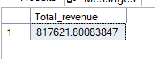

2. Average Order Value
SELECT CAST(CAST(SUM(TOTAL_PRICE) AS DECIMAL(10,2)) /
CAST(COUNT(DISTINCT ORDER_ID) AS DECIMAL(10,2)) AS DECIMAL(10,2))
AS AVG_ORDER_VALUE
FROM PIZZA_SALES;
Output

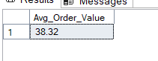
3. Total Pizzas Sold
SELECT SUM(QUANTITY) AS TOTAL_PIZZA_SOLD FROM PIZZA_SALES;
Output

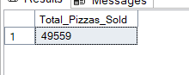

4. Total Orders
SELECT COUNT(DISTINCT ORDER_ID) AS TOTAL_ORDERS FROM PIZZA_SALES;
Output

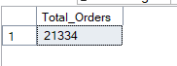

5. Average Pizzas Per Order
SELECT CAST(CAST(SUM(QUANTITY) AS DECIMAL(10,2))/
CAST(COUNT(DISTINCT ORDER_ID) AS DECIMAL(10,2))
AS DECIMAL(10,2)) AS AVG_PIZZA_PER_ORDER FROM PIZZA_SALES;
Output

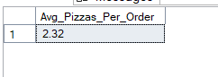

B. Visuals
1. Daily Trend for Total Orders
SELECT datename(WEEKDAY,ORDER_DATE) AS DAY, COUNT(DISTINCT ORDER_ID) AS TOTAL_ORDERS
FROM PIZZA_SALES
GROUP BY datename(WEEKDAY,ORDER_DATE);
Output:
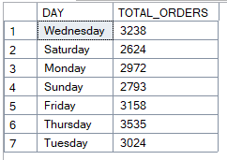
2. Monthly Trend for Total revenue
select datename(MONTH,order_date) as Monthly_Trend
, cast(SUM(total_price) as decimal(10,2)) as Total_revenue
from pizza_sales
group by datename(MONTH,order_date);
Output
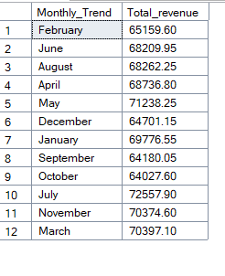
3. % of Sales by Pizza Category
SELECT pizza_category,
CAST(SUM(TOTAL_PRICE) AS DECIMAL(10,2)) as Total_Revenue,
cast(SUM(TOTAL_PRICE) * 100
/(SELECT SUM(TOTAL_PRICE) FROM PIZZA_SALES) as decimal(10,2))
as Percentage_Pizza_Catgy
FROM pizza_sales
GROUP BY pizza_category;
Output
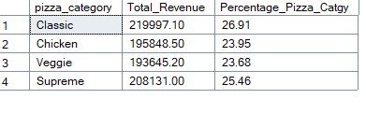
4. % of Sales by Pizza Size
SELECT pizza_size,
CAST(SUM(TOTAL_PRICE) AS DECIMAL(10,2)) as Total_Revenue,
cast(SUM(TOTAL_PRICE) * 100
/(SELECT SUM(TOTAL_PRICE) FROM PIZZA_SALES) as decimal(10,2))
as Percentage_Pizza_size
FROM pizza_sales
GROUP BY pizza_size;
Output
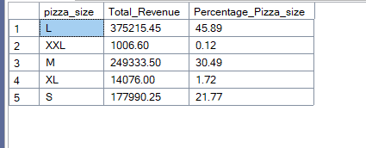
5. Total Pizzas Sold by Pizza Category
SELECT pizza_size, SUM(quantity) as Total_Sold_Size
FROM pizza_sales
GROUP BY pizza_size;

SELECT pizza_category, SUM(quantity) as Total_Sold_Categy
FROM pizza_sales
GROUP BY pizza_category;

Output
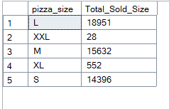
Output
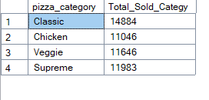
6. Top 5 Pizzas by Revenue
SELECT TOP 5 PIZZA_NAME, SUM(TOTAL_PRICE) AS TOTAL_REVENUE
FROM PIZZA_SALES
GROUP BY PIZZA_NAME
ORDER BY TOTAL_REVENUE DESC;
Output
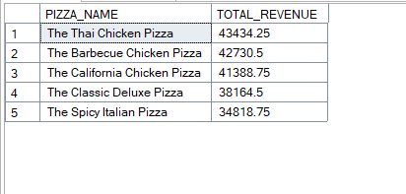

7. Bottom 5 Pizzas by Revenue
SELECT TOP 5 PIZZA_NAME, SUM(TOTAL_PRICE) AS TOTAL_REVENUE
FROM PIZZA_SALES
GROUP BY PIZZA_NAME
ORDER BY TOTAL_REVENUE ASC;

Output
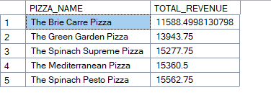

8. Top 5 Pizzas by Quantity
SELECT TOP 5 PIZZA_NAME, SUM(QUANTITY) AS TOTAL_QUANTITY
FROM PIZZA_SALES
GROUP BY PIZZA_NAME
ORDER BY TOTAL_QUANTITY DESC;
Output
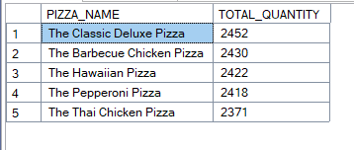

9. Bottom 5 Pizzas by Quantity
SELECT TOP 5 PIZZA_NAME, SUM(QUANTITY) AS TOTAL_QUANTITY
FROM PIZZA_SALES
GROUP BY PIZZA_NAME
ORDER BY TOTAL_QUANTITY ASC;
Output
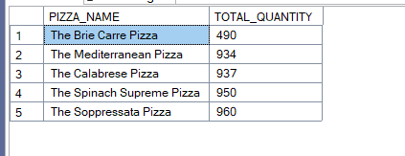
10. Top 5 Pizzas by Total Orders

SELECT TOP 5 PIZZA_NAME, COUNT(DISTINCT ORDER_ID) AS TOTAL_ORDERS
FROM PIZZA_SALES
GROUP BY PIZZA_NAME
ORDER BY TOTAL_ORDERS DESC;

Output
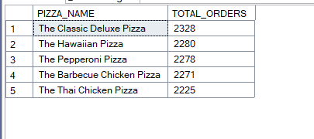

11. Bottom 5 Pizzas by Total Orders

SELECT TOP 5 PIZZA_NAME, COUNT(DISTINCT ORDER_ID) AS TOTAL_ORDERS
FROM PIZZA_SALES
GROUP BY PIZZA_NAME
ORDER BY TOTAL_ORDERS ASC;

Output
